Defects :

Defect ID_01:

The <https://www.google.com> URL is not accessible .

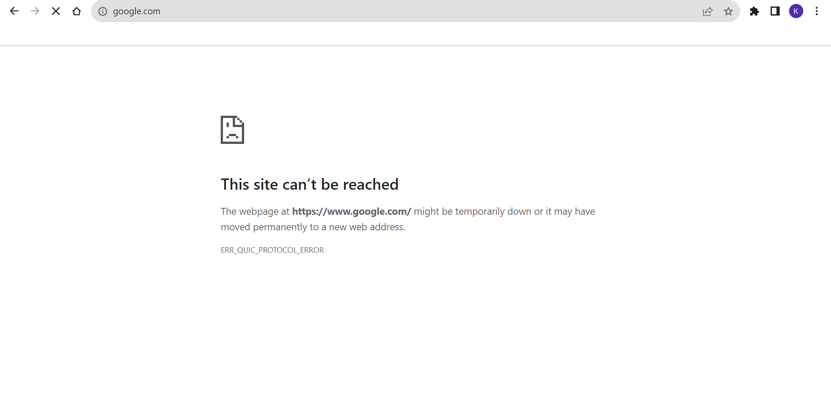

It’s a high Protity - Showstopper defect .